PARENT NOTIFICATION APP
@CREATIVITY THINK (9483175986/7019689991)

ABSTRACT:
Parent Notification App is a web-based system designed to facilitate communication between educational institutions and parents. The platform enables sending and receiving notices, tracking responses, and managing parent-child linkages efficiently. Users can view action history and dashboard analytics, while administrators manage links, notifications, and templates. Built with Django and Django Rest Framework on the backend, and React with redux and socket.io on the frontend, the system ensures real-time updates, secure message delivery, and actionable insights for better parental engagement..

INTRODUCTION OF THE PROJECT:
Schools, hostels, and learning centers often struggle with timely communication with parents. Traditional methods like paper notices or emails are inefficient, lack tracking, and may not reach parents promptly. The Parent Notification App addresses these challenges by providing a centralized platform for instant notifications, real-time response tracking, and analytics. It strengthens engagement, ensures accountability, and offers administrators full visibility of communication workflows..

PROJECT OBJECTIVES:

• Enable real-time sending and receiving of notices
• Establish secure parent-child linkages
• Track parent responses and actions
• Provide interactive dashboards for users and admins
• Allow administrators to manage alerts and notification templates
• Ensure secure, efficient, and traceable communication
• Support analytics-driven insights for engagement metrics
• Enhance parent-school communication efficiency

PROBLEM OF THE STATEMENT:
Communication gaps between institutions and parents often result in missed notifications, delayed responses, and inadequate engagement. Manual systems are time-consuming and do not provide actionable insights. The Parent Notification App resolves these issues by offering instant notice delivery, response tracking, and analytics, ensuring a structured and reliable communication workflow..

MOTIVATION OF THE PROJECT:
• To replace manual and paper-based notifications with a digital system
• To ensure real-time delivery of notices to parents
• To provide transparency through response tracking
• To improve parental engagement and accountability
• To empower administrators with analytical insights
• To streamline the communication workflow efficiently
• To create a scalable solution for schools and hostels

BLOCK DAIGRAM OF PROJECT:

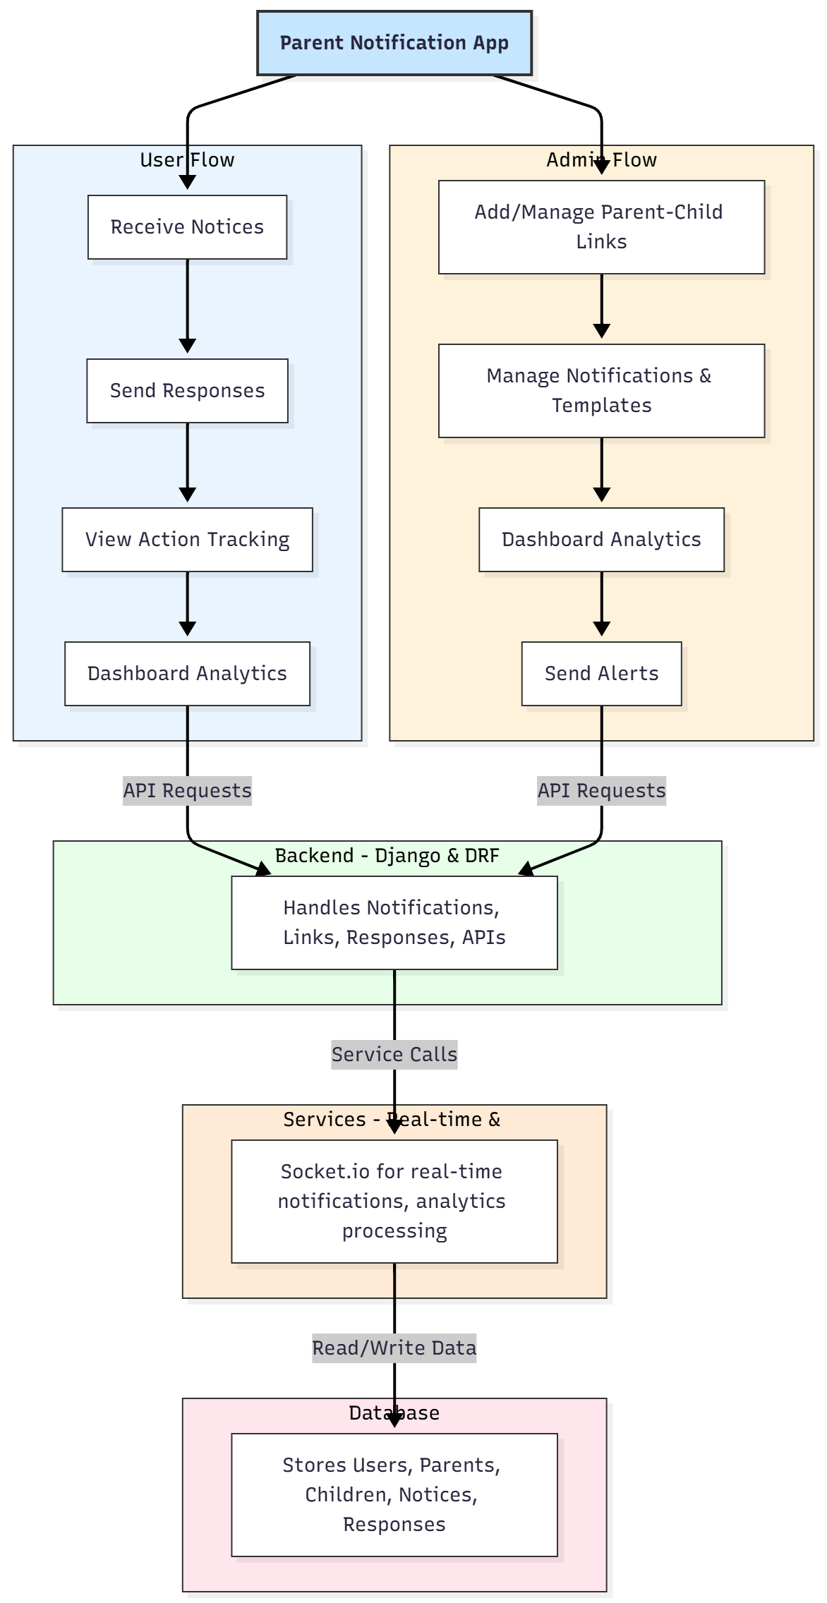

WORKING OF THE PROJECT:
The system begins with administrators linking parents and children within the platform. Notices are created using templates or custom messages and delivered instantly through socket.io for real-time updates. Parents receive notices and can respond directly within the application. Responses and actions are tracked and displayed in dashboards for both users and admins. The backend manages notifications, parent-child linkages, and analytics, while the database stores all structured information. This workflow ensures secure, transparent, and actionable communication between institutions and parents..

SOFTWARE REQUIREMENT:
- Backend:
  - Python 3.x
  - Django
  - Django REST Framework
  - SQLite/PostgreSQL
- Frontend:
  - Node.js and npm
  - React.js
  - Axios
- Development Tools:
  - Visual Studio Code
  - Postman (for testing APIs)
  - Git/GitHub (for version control)
- Server/Deployment (Optional):
  - Gunicorn, Nginx, or Heroku/AWS for hosting

ADVANTAGES OF THE PROJECT:

• Real-time delivery and response tracking
• Transparent parent-child communication
• Customizable notification templates
• Dashboard analytics for engagement insights
• Reduced manual effort and improved efficiency
• Secure and centralized communication
• Scalable for multiple institutions
• Supports accountability and timely actions

APPLICATIONS OF THE PROJECT:
• Schools and educational institutions
• Hostels and boarding facilities
• Learning centers
• Teacher-parent communication
• Emergency alerts and notifications
• Student progress and attendance notifications

REFERENCES:

- Django REST Framework Documentation — Django Software Foundation. Django Documentation. Available: https://docs.djangoproject.com/
- Django REST Framework. DRF Documentation. Available: https://www.django-rest-framework.org/
- React. React Official Documentation. Available: https://reactjs.org/docs/getting-started.html
- Redux. Redux Documentation. Available: https://redux.js.org/introduction/getting-started
- PostgreSQL Global Development Group. PostgreSQL Documentation. Available: https://www.postgresql.org/docs/
- MySQL. MySQL Reference Manual. Available: https://dev.mysql.com/doc/
- Git. Git Documentation. Available: https://git-scm.com/doc
- Node.js. Node.js Documentation. Available: https://nodejs.org/en/docs/
- Axios. Axios Documentation. Available: https://axios-http.com/docs/intro
- Socket.io Documentation – https://socket.io/docs/

